The report
Section A: Directory structure
Figure.1:
Coursework location Local Disk (C:) > xampp > htdocs >19095713(OwenPark).
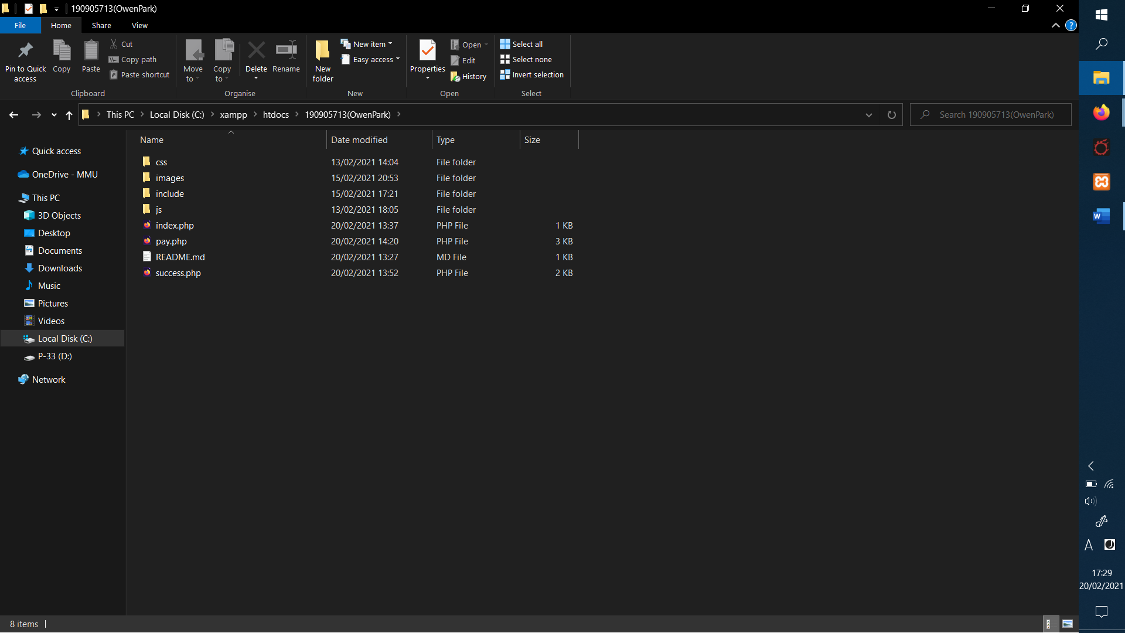

Figure.2:
Inside of the main folder ‘19095713(OwenPark)’, there are 4 folders, titled ‘css’, ‘images’, ‘include’, and ‘js’.
As per instructions, the css folder contains one single css file, titled ‘style.css’ and it is linked to all pages to keep the style of the website consistent.
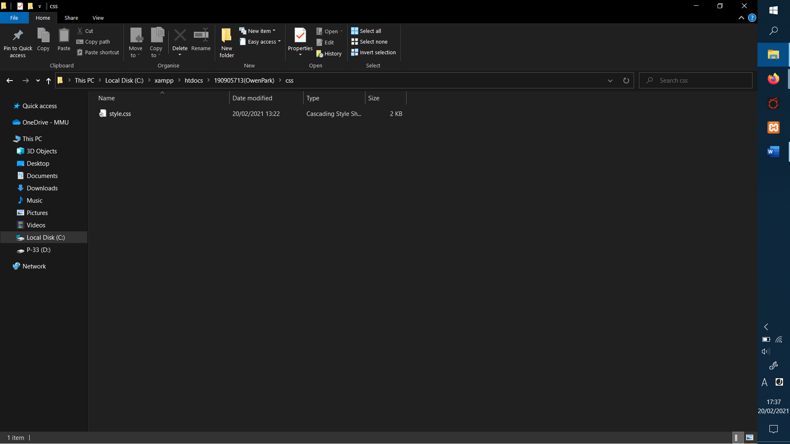

Figure.3:
Images has two folders inside of it, titled ‘books’ and ‘logo’.
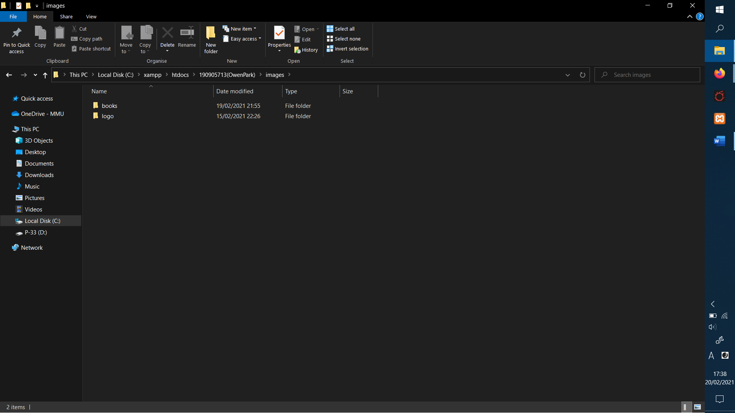

Figure.4:
‘Books’ folder contents, the four books used in the website.
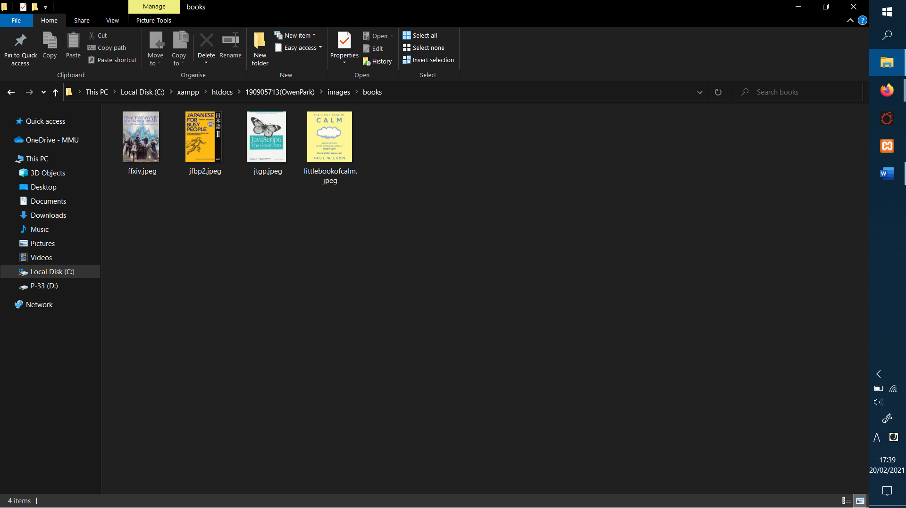

Figure.5:
The ‘logo’ folder contents, an image from the TV show ‘Black Books’ (a comedy about a book shop), and a Mastercard logo. The logo.jpeg was made to be the fake store’s logo and Mastercard for the website and pay section.
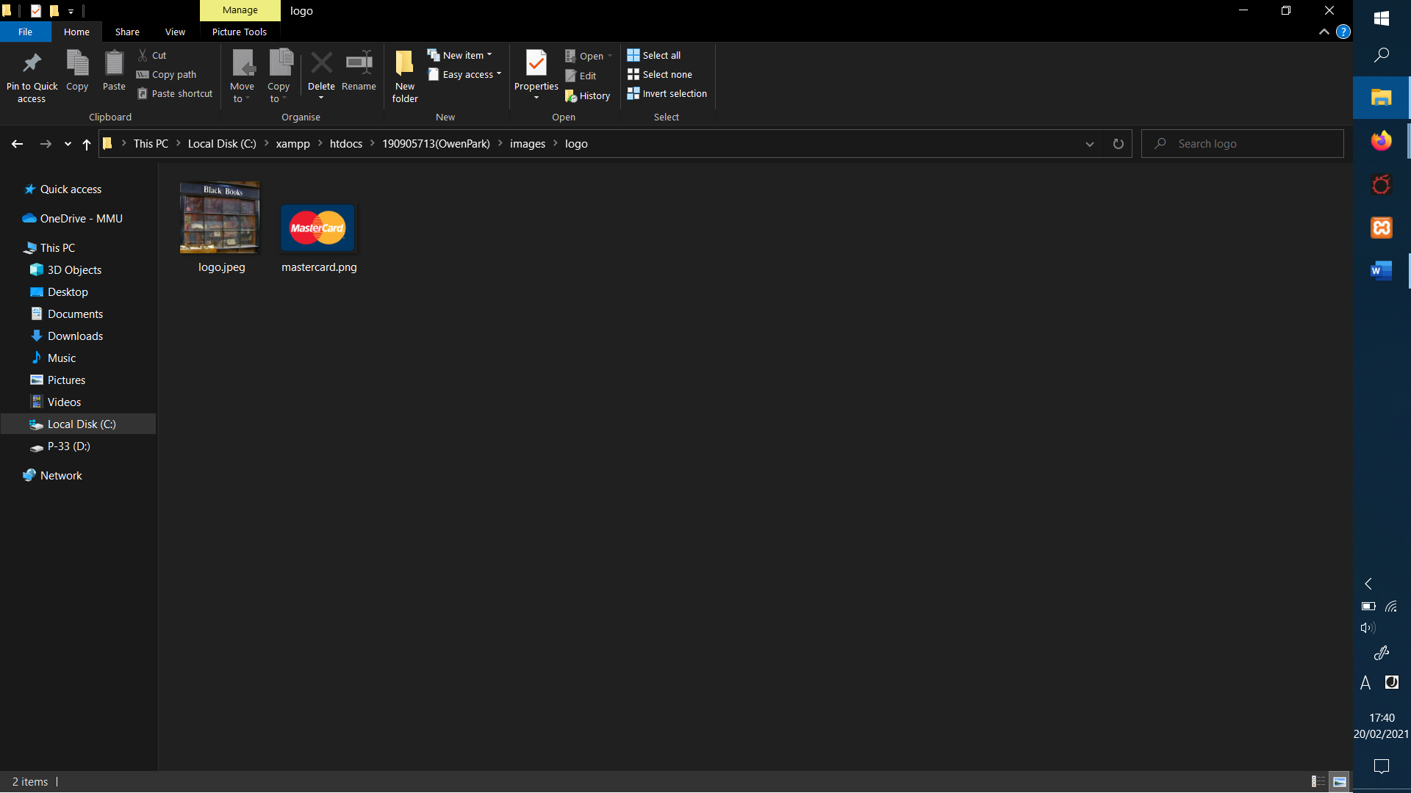

Fig.6:
The next folder is the ‘include’ folder with two files: ‘books.php’ and ‘header.php’. The ‘header.php’ keeps the code for the header so there is no need to type it in more than once. The ‘books.php’ contains the books as they weren’t specified as being needed in the database.
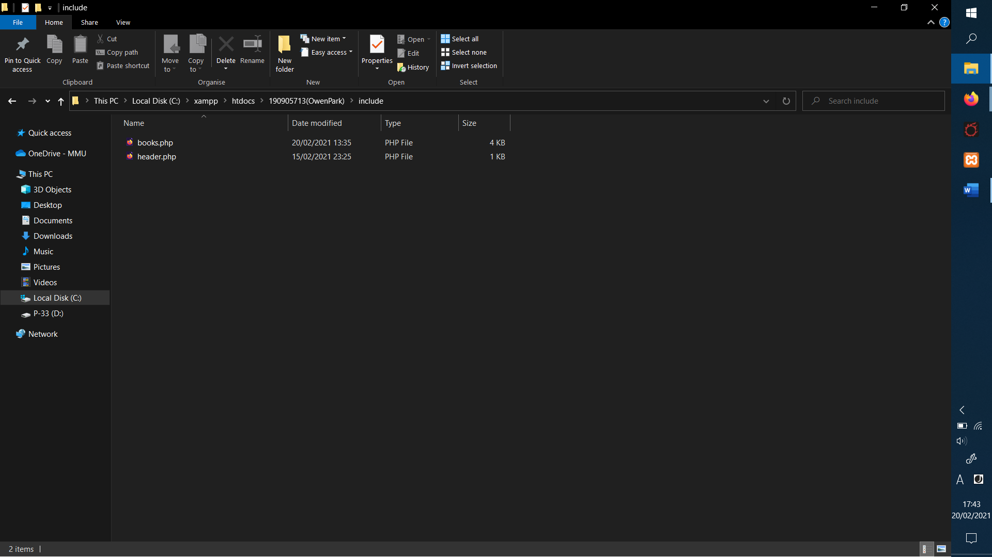

Figure.7:
The ‘js’ folder has a single JavaScript file inside called ‘validate.js’.
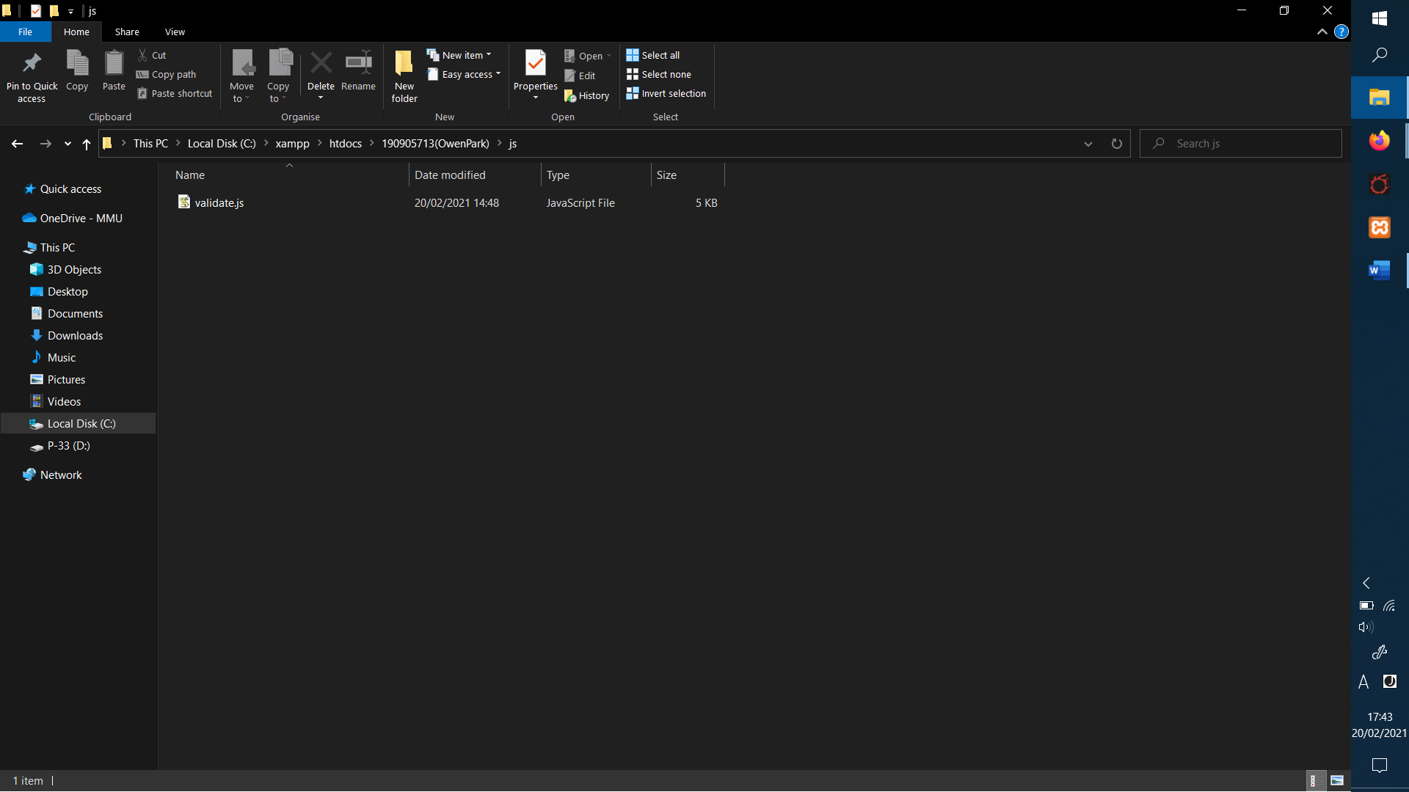

Finally, as seen in Figure.1, the remainder files are inside the main folder ‘19095713(OwenPark), called ‘index.php’, ‘pay.php’, ‘README.md’ (dominantly blank document made when I made a private repository in Github), and ‘success.php’.

Section B: Frontend

Figure.8:
The homepage ‘index.php’, desktop mode (books in rows of 2 as stated in specification).
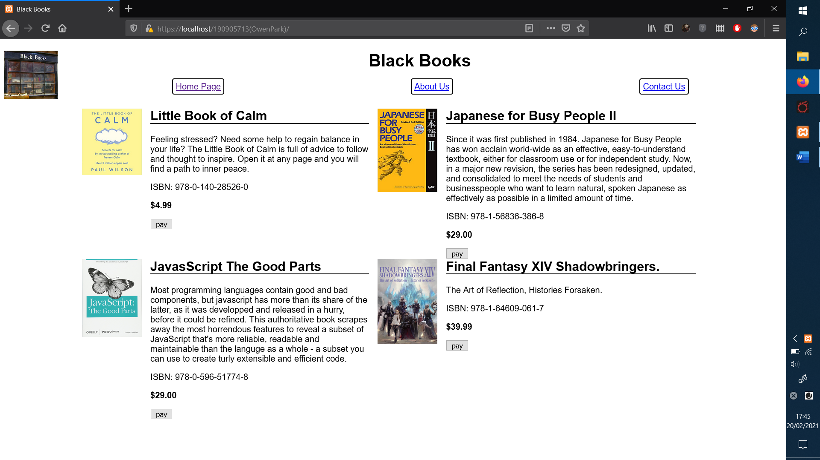

Figure.9:
And mobile version (single rows, as stated in specification).
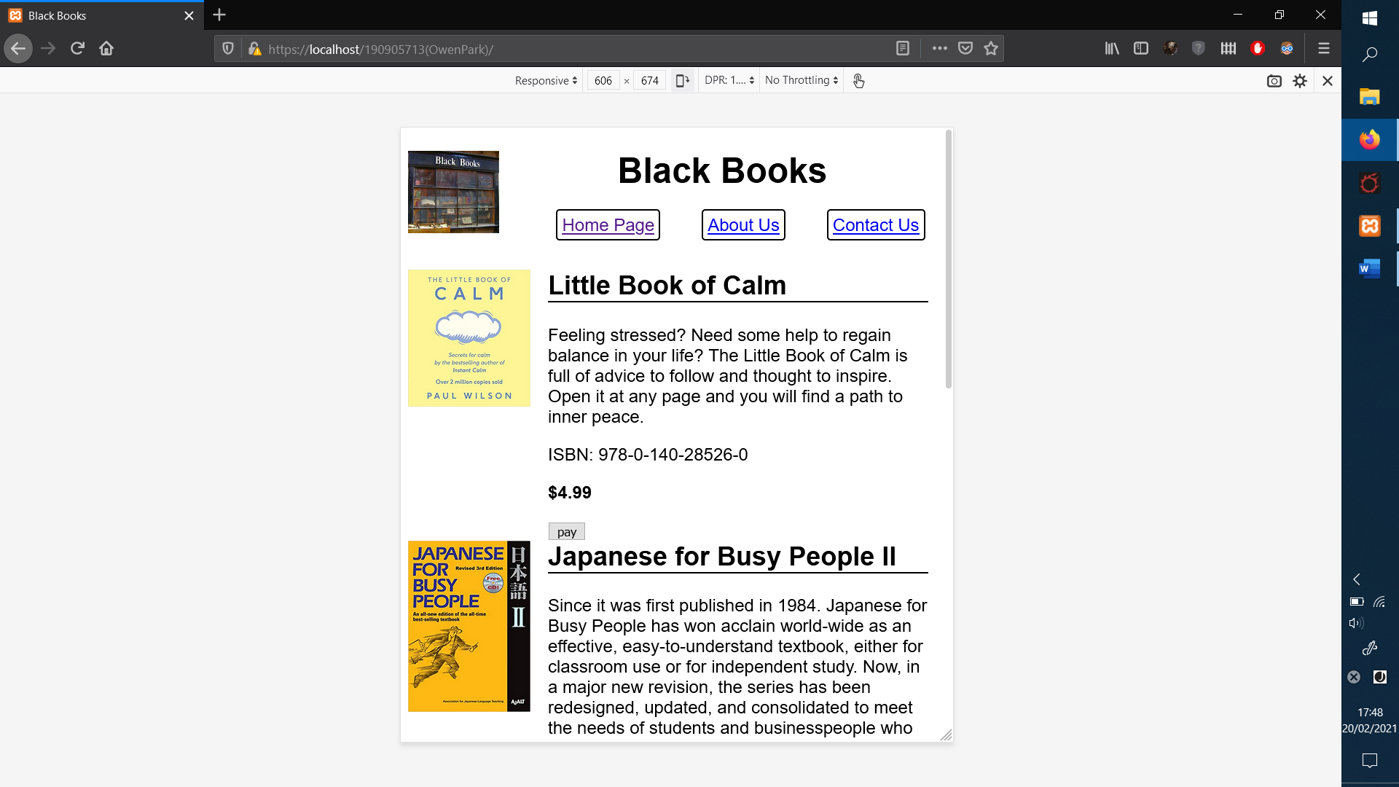

Figure.10:
When clicked on ‘pay’ redirected to pay.php.
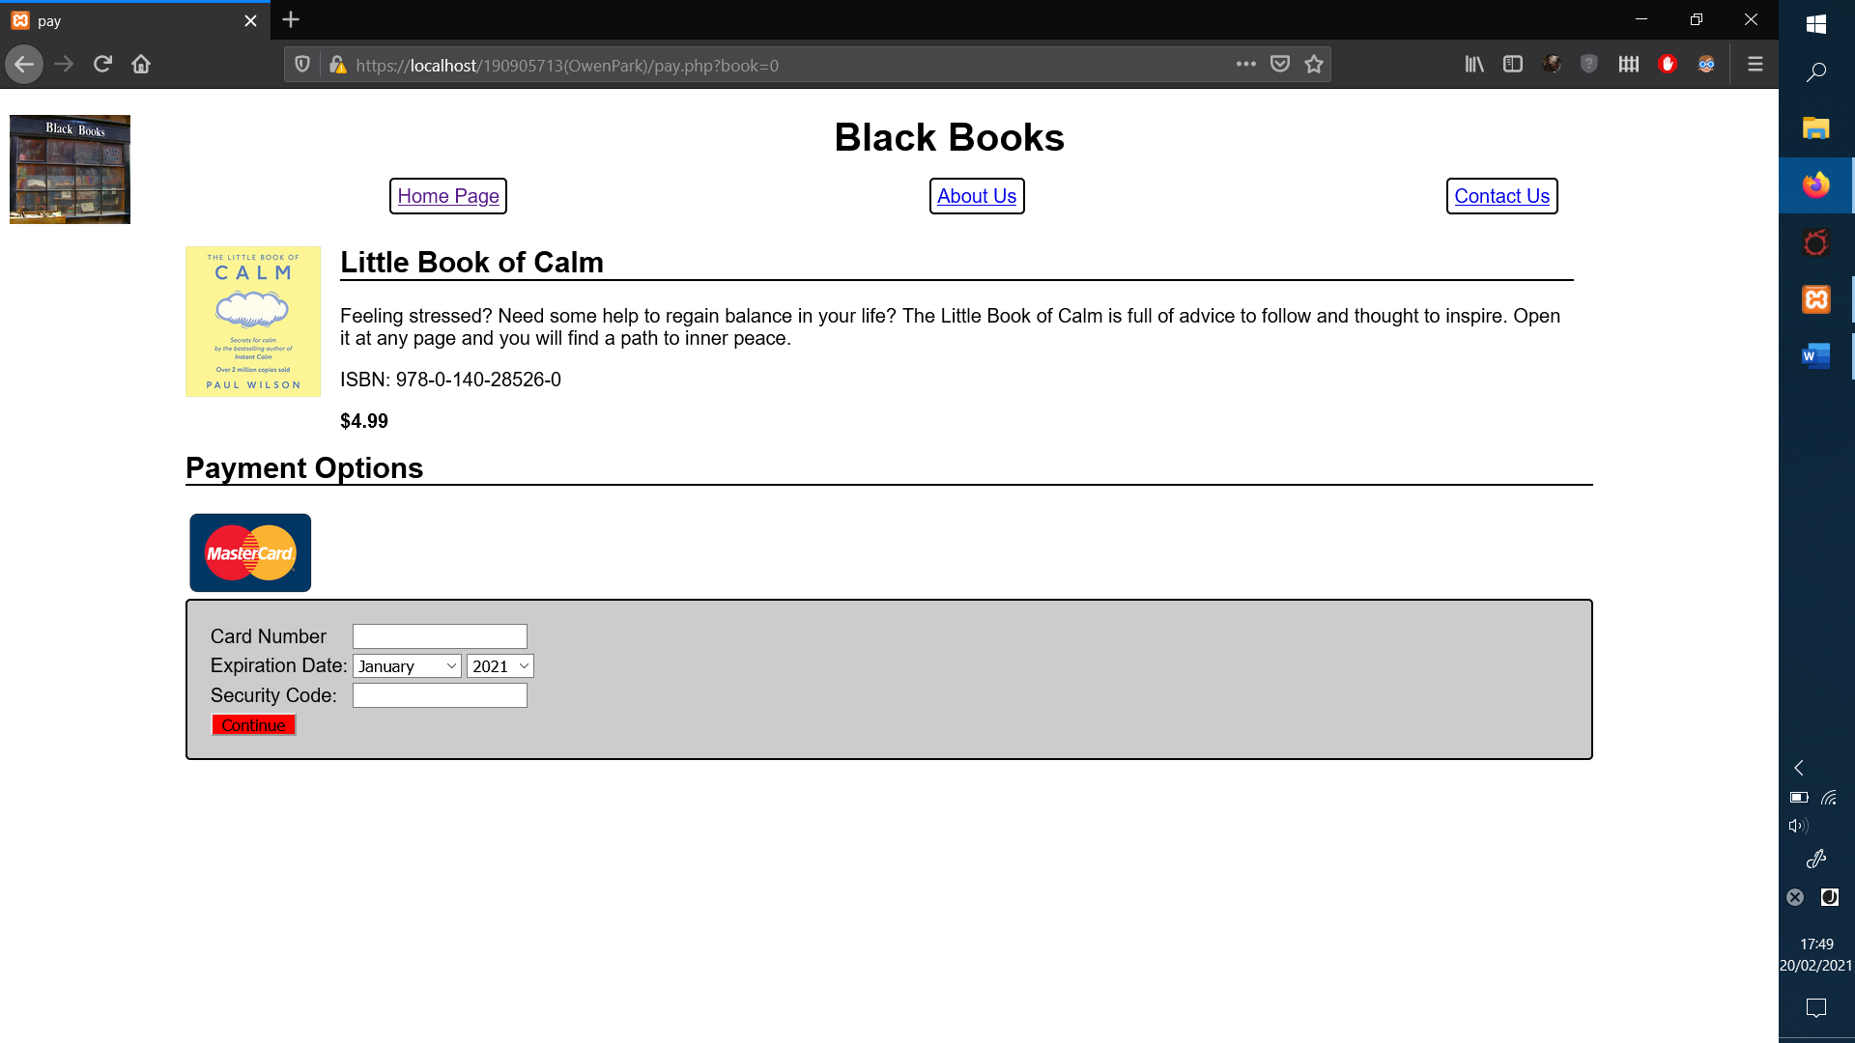

Figure.11.a, Figure.11.b, and Figure.11.c:
When valid information is given(Figure11.a).
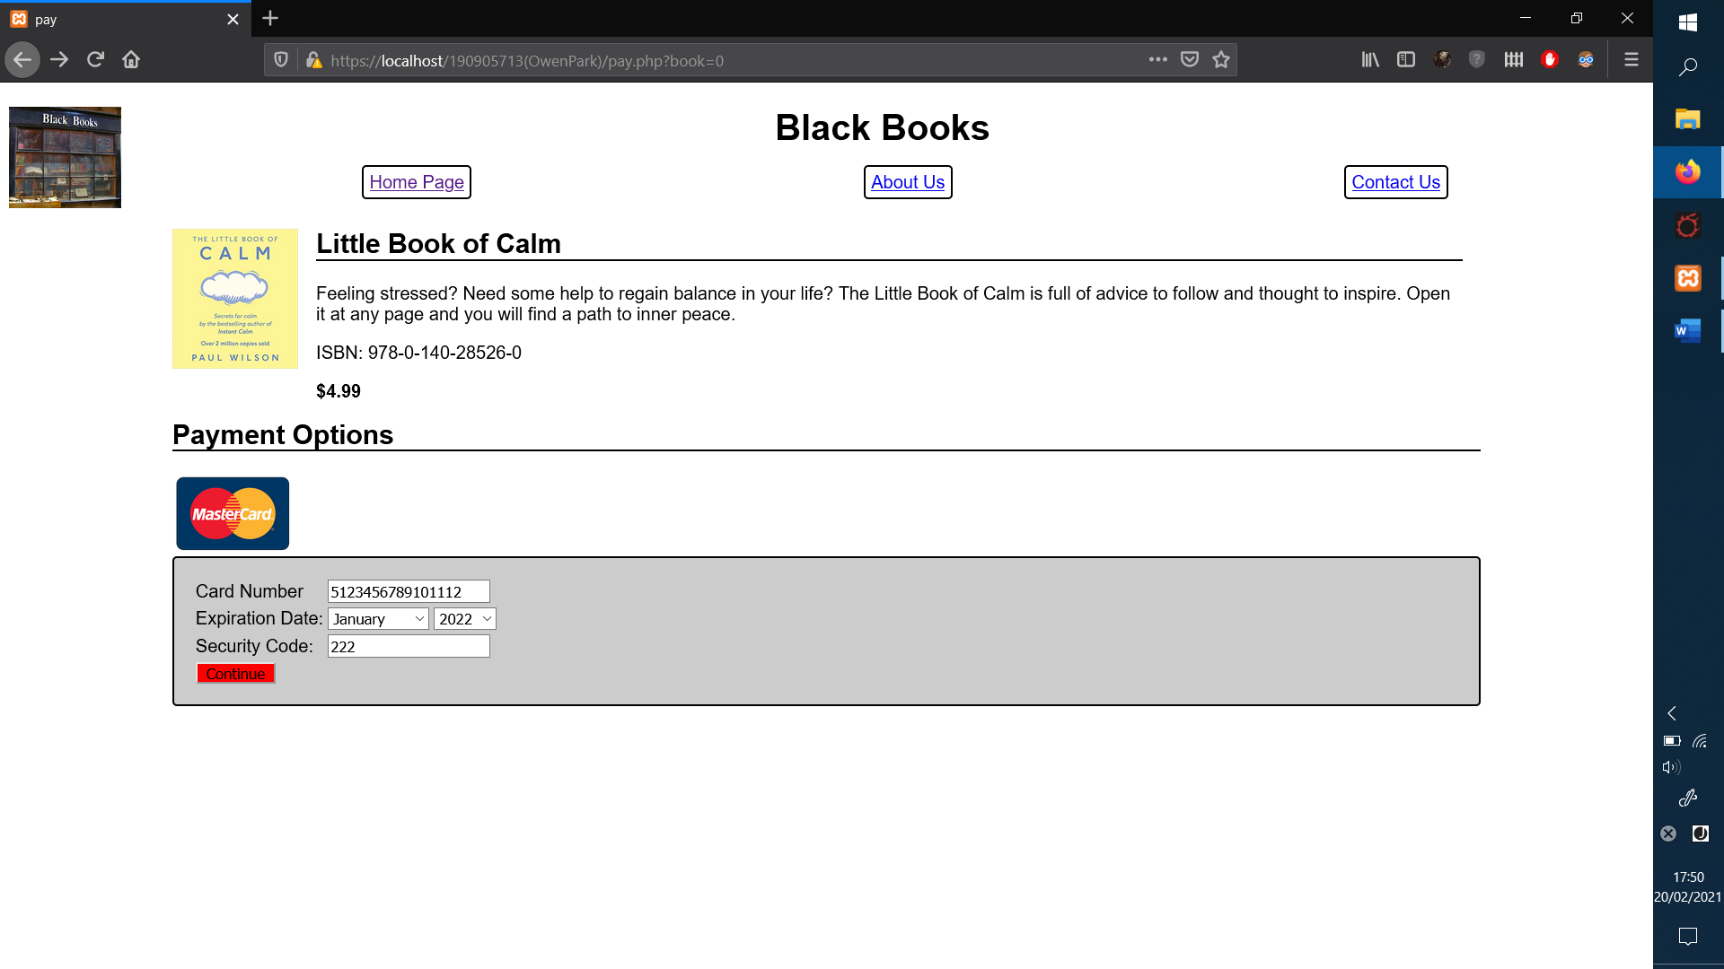
it validates(Figure11.b), displaying ‘success.php’.
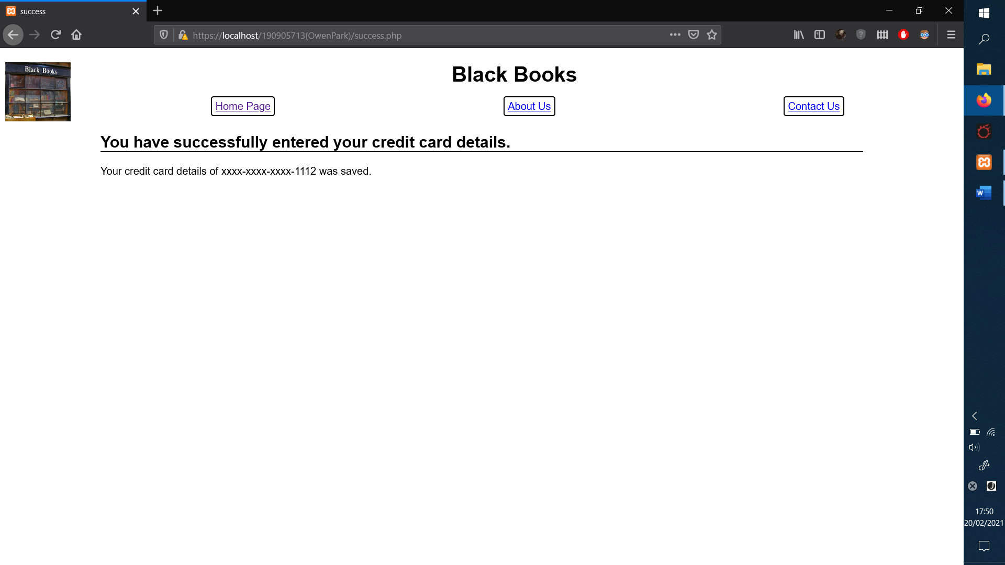

and adds to database (Figure.11.c).
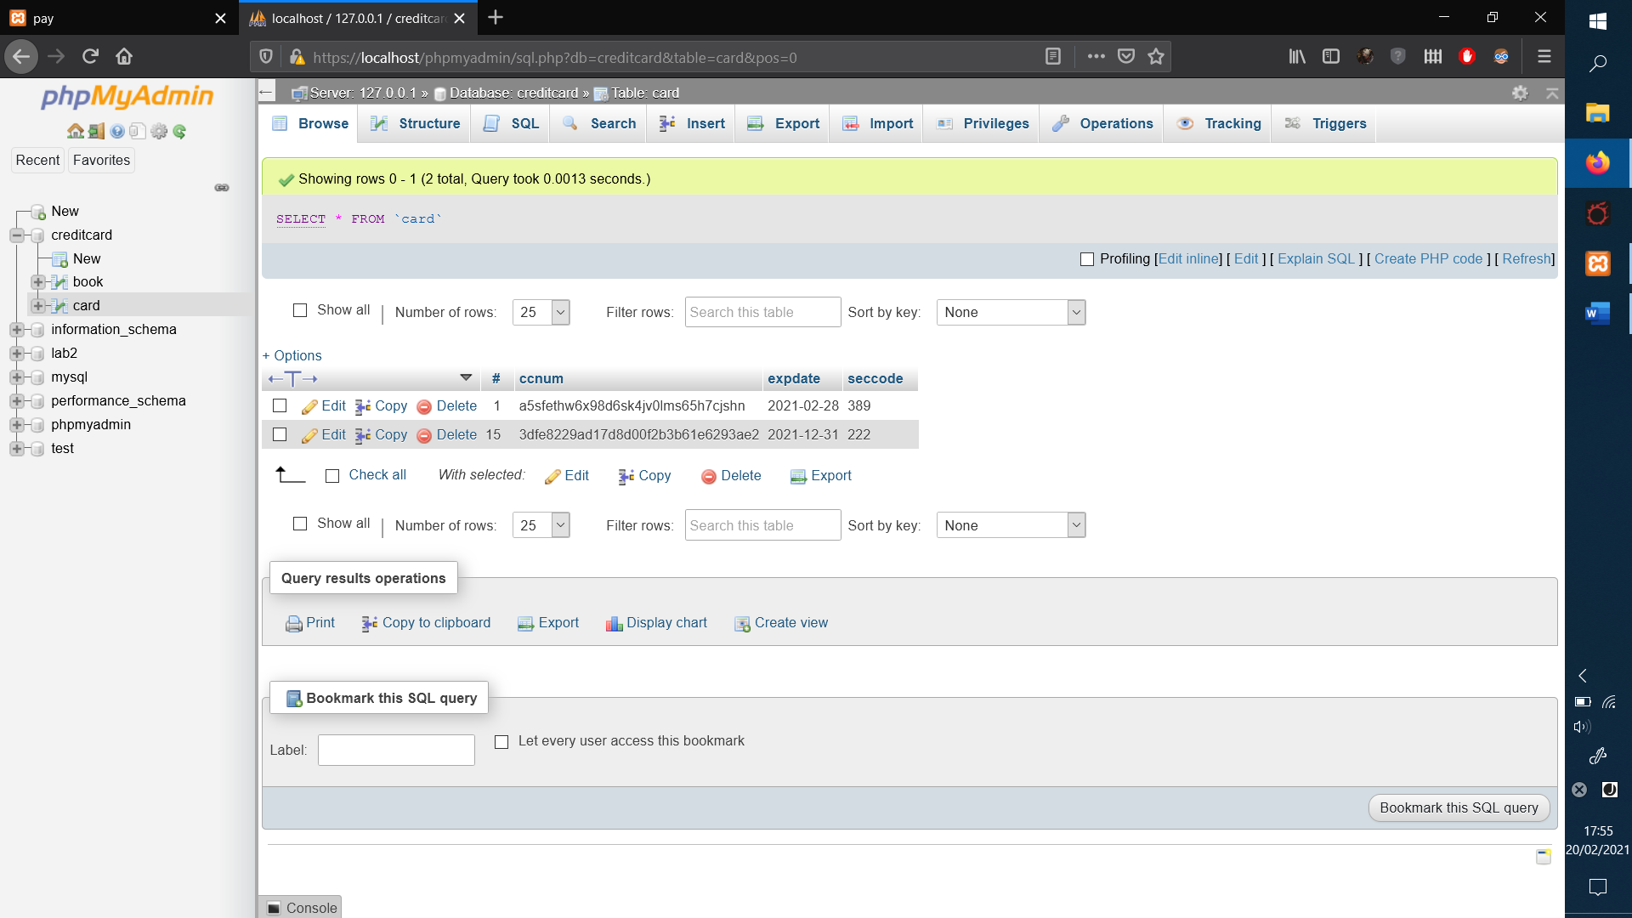

Figure.12.a and Figure.12.b:
A failing card, depending on what has failed, user will receive a message (Figure.12.a: all failures done here to showcase them at once).

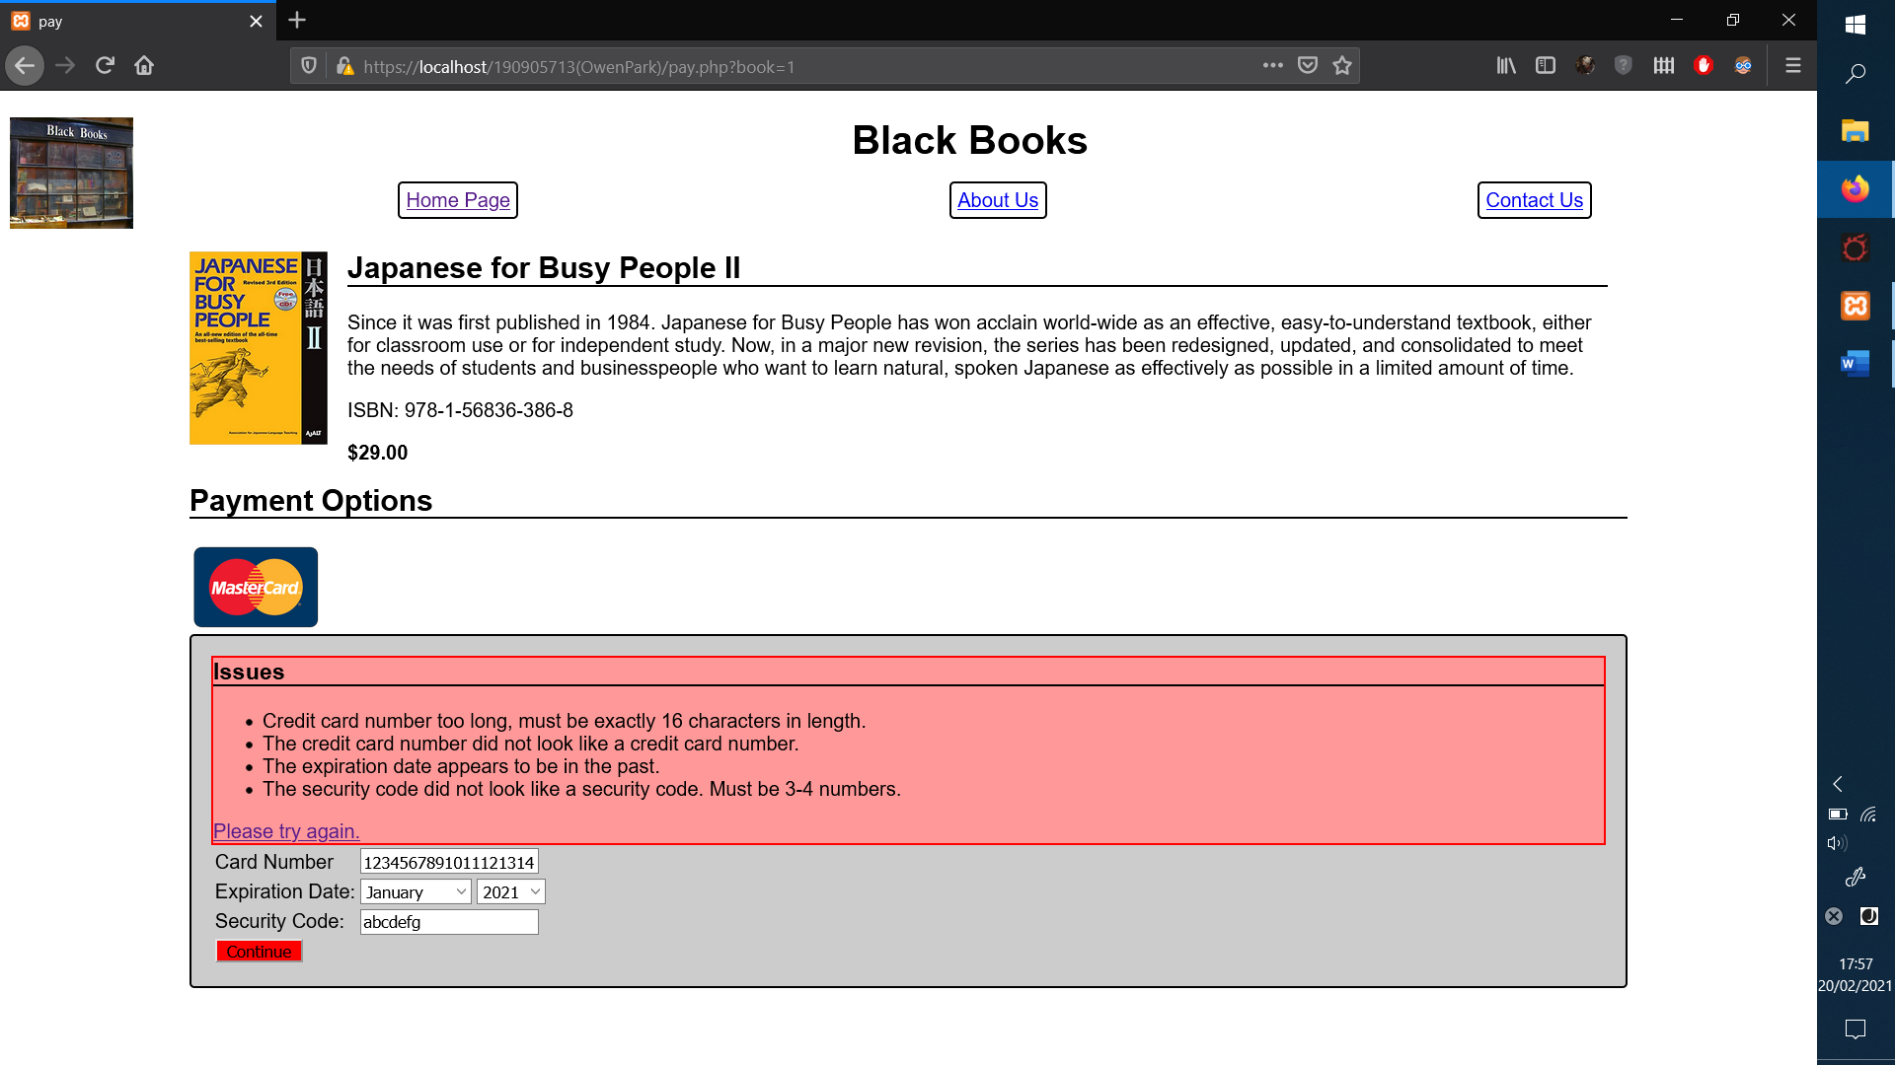
Figure.12.b: Example of failing one measure (Security code inputted was 3 letters, thus invalid and error message displayed):

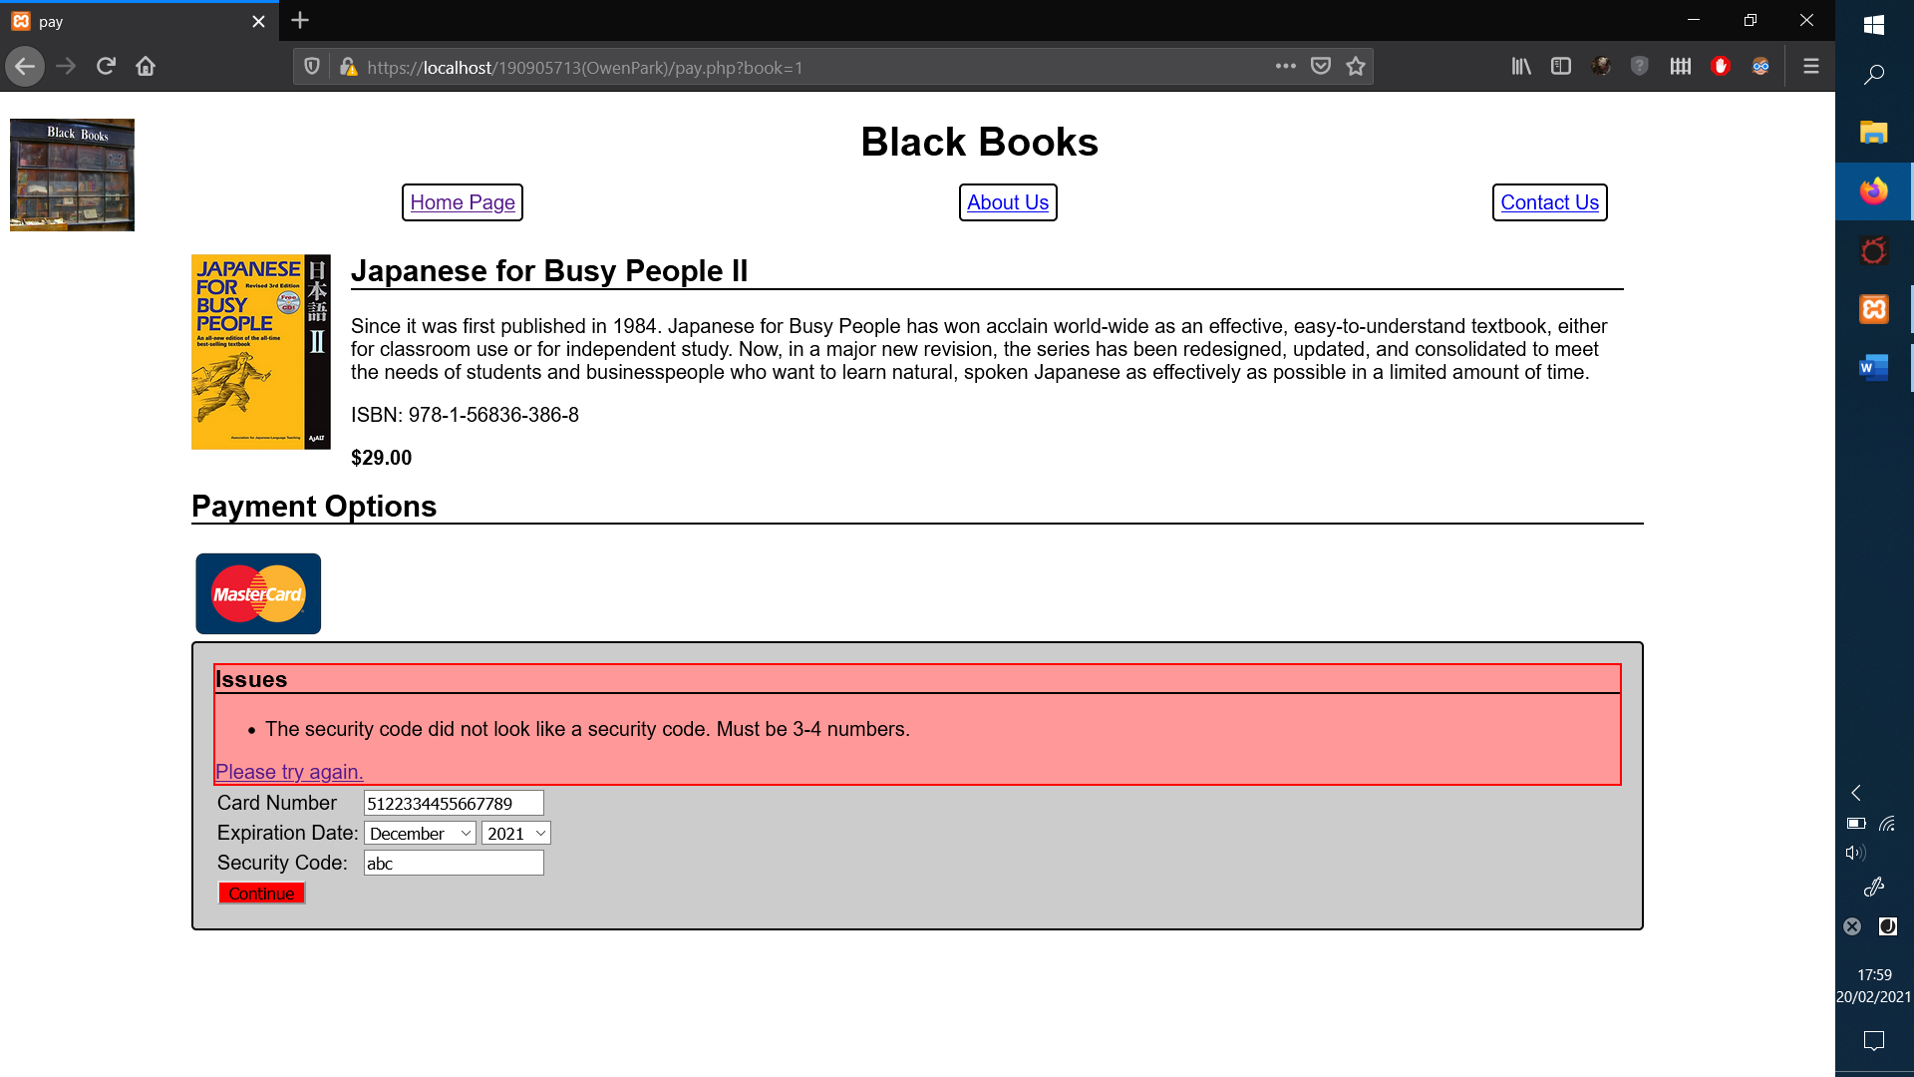
Figure.14:
‘Try again’ is a hyperlink that returns user to the same book buying page again, with all information removed from the input areas:
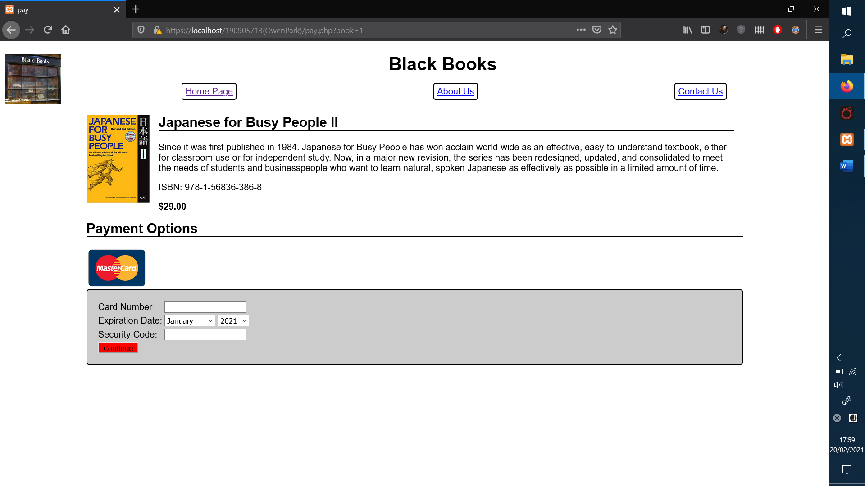

Section C: Backend.
Figure.15:
Screenshot of the database table illustrating the credit card data inserted into the appropriate columns.
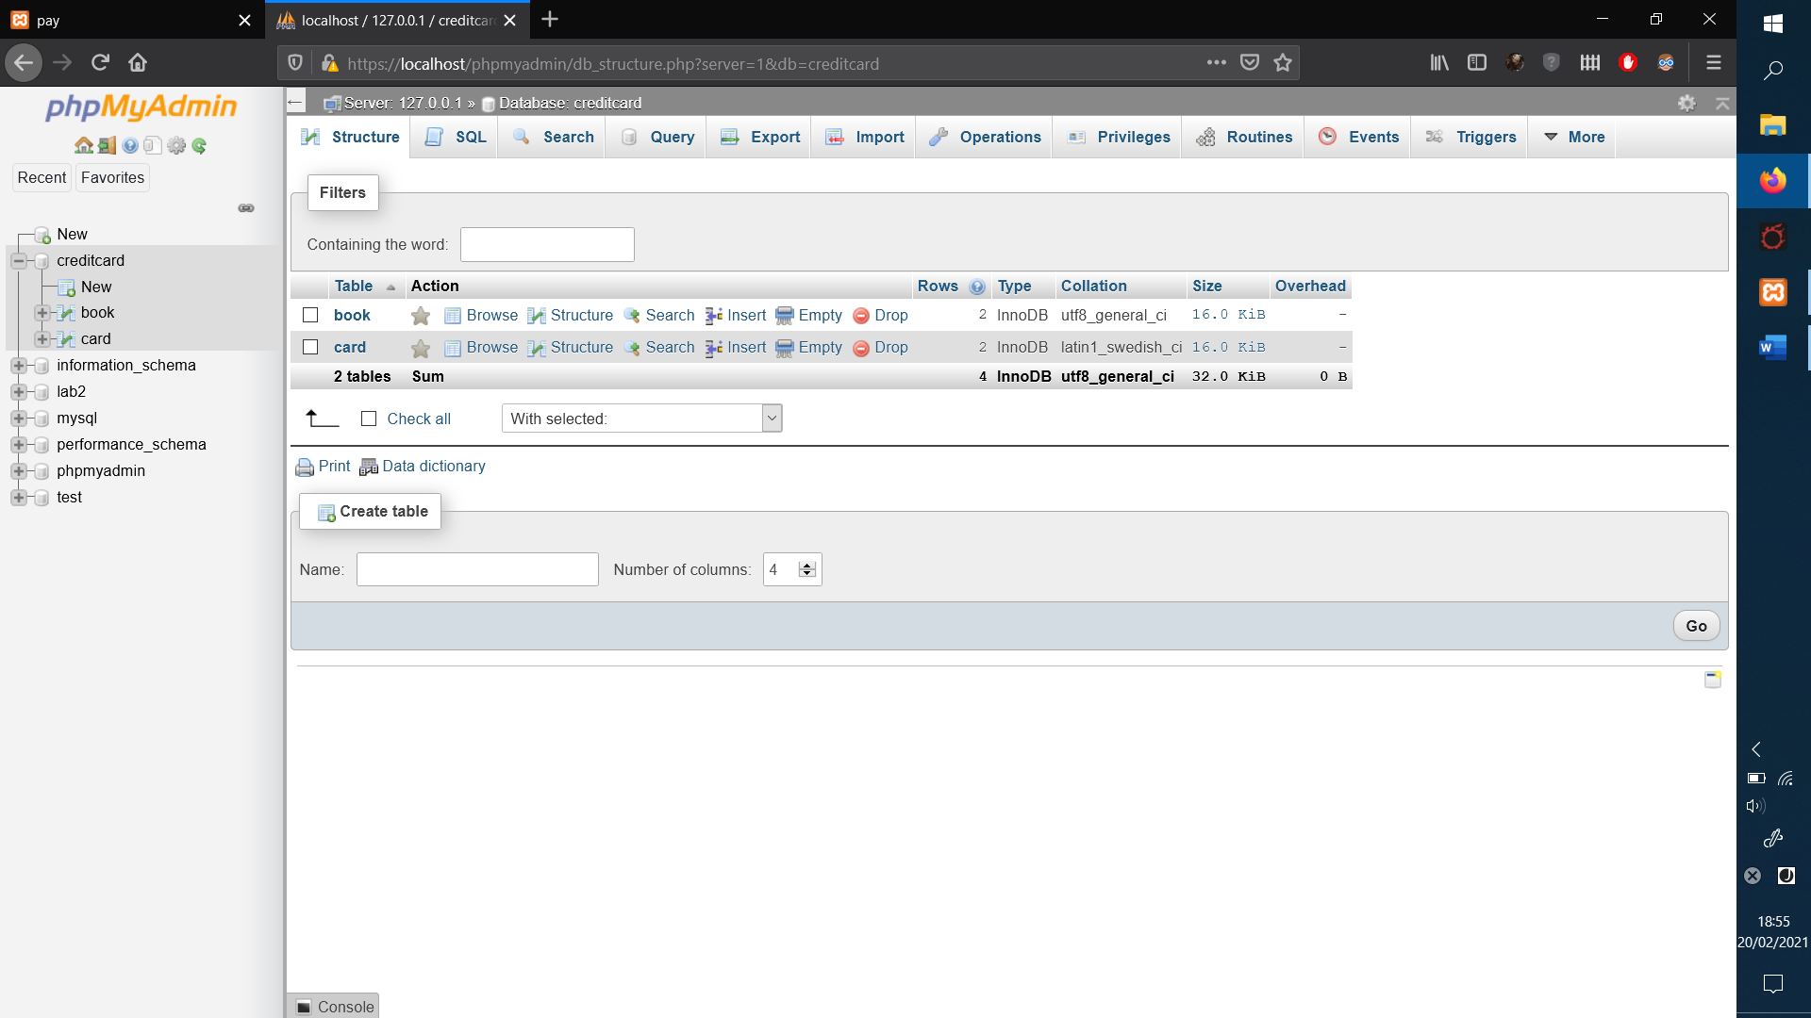

Section D: Code appendix

style.css

/* The css style page */

body {
font-family: Helvetica, Ubuntu, sans-serif;
color: #000000;
background: #FFFFFF;
}
main {
margin: 0 10%;
padding-top: 1em;
}

h2,h3,h4 {
border-bottom: solid 2px #000000;
margin-top:0;
}

.bookImage{
display: block;
width: 7em;
}

#globalHeader h1{
text-align: center;

}
#globalHeader img{
width: 100px;
float: left;
}
#globalHeader nav ul{

display: grid;
grid-template-columns: auto auto auto;
text-align: center;
list-style-type:none;
}
#globalHeader nav a{
border: 2px solid #000000;
border-radius: 4px;
padding: 5px;
}

.hidden{
display: none;
}

.booksList{
display: grid;
grid-template-columns: auto auto;
}

.bookBlock {
display: grid;
grid-template-columns: 7em auto;
margin: 0;
}
.bookBlock figcaption {
padding: 0 1em;
}
.bookPrice {
font-weight: bold;
}

#paymentOptions img{
height: 70px;

}

#myForm{
background: #CCCCCC;
border: 2px solid #000000;
border-radius: 4px;
padding: 1em;

}
#continueButton{
background-color: #FF0000;

}
#issues {
background: #FF9999;
border: solid 2px #FF0000;
}

@media screen and (max-width: 800px) {
body{
font-size: 1.2em;
}
main {
margin: 0;
}
.booksList{
display: block;
}
}

books.php

<?php
/* A books database.
It would be best to store these details in the real database, but I cant be sure the tutor will have time to load our custom database file.
*/

class Book {
public $title;
public $description;
public $author;
public $price;
public $image;
public $isbn;
function __construct($argv) {
$this->title = $argv['title'];
$this->description = $argv['description'];
$this->author = $argv['author'];
$this->price = $argv['price'];
$this->image = $argv['image'];
$this->isbn = $argv['isbn'];
}

//Produces markup for book widget
function figure($index=-1) {
$paybtn = "";
if ($index > -1) {
$paybtn = <<<EOF
<form method='get' action='pay.php'>
<input type='hidden' name='book' value='{$index}' />
<input type='submit' value='pay'/>
</form>
EOF;
}
echo <<<EOF
<figure class='bookBlock'>
<img class='bookImage' src='images/books/{$this->image}' alt='Cover for {$this->title}'>
<figcaption>
<header class='bookTitle'><h2>{$this->title}</h2></header>
<p class='bookDescription'>{$this->description}</p>
<p class='bookIsbn'>ISBN: {$this->isbn}</p>
<p class='bookPrice'>{$this->price}</p>
{$paybtn}
</figcaption>
</figure>

EOF;

}
}

//The array of books
$bookArr = array(
new Book(array(
'title' => 'Little Book of Calm',
'description' => 'Feeling stressed? Need some help to regain balance in your life? The Little Book of Calm is full of advice to follow and thought to inspire. Open it at any page and you will find a path to inner peace.',
'author' => 'Paul Wilson',
'price' => '$4.99',
'image' => 'littlebookofcalm.jpeg',
'isbn' => '978-0-140-28526-0'
)),
new Book(array(
'title' => 'Japanese for Busy People II',
'description' => 'Since it was first published in 1984. Japanese for Busy People has won acclain world-wide as an effective, easy-to-understand textbook, either for classroom use or for independent study. Now, in a major new revision, the series has been redesigned, updated, and consolidated to meet the needs of students and businesspeople who want to learn natural, spoken Japanese as effectively as possible in a limited amount of time.',
'author' => 'Association for Japanese-Language Teaching',
'price' => '$29.00',
'image' => 'jfbp2.jpeg',
'isbn' => '978-1-56836-386-8'
)),
new Book(array(
'title' => 'JavasScript The Good Parts',
'description' => 'Most programming languages contain good and bad components, but javascript has more than its share of the latter, as it was developped and released in a hurry, before it could be refined. This authoritative book scrapes away the most horrendous features to reveal a subset of JavaScript that\'s more reliable, readable and maintainable than the languge as a whole - a subset you can use to create turly extensible and efficient code.',
'author' => 'Douglas Crockford',
'price' => '$29.00',
'image' => 'jtgp.jpeg',
'isbn' => '978-0-596-51774-8'
)),
new Book(array(
'title' => 'Final Fantasy XIV Shadowbringers.',
'description' => 'The Art of Reflection, Histories Forsaken.',
'author' => 'Square Enix Co. Ltd.',
'price' => '$39.99',
'image' => 'ffxiv.jpeg',
'isbn' => '978-1-64609-061-7'
)),
);

?>

header.php

<header id="globalHeader">
<img src="images/logo/logo.jpeg" alt="Black Books Store Front Logo">
<h1>Black Books</h1>
<nav>
<ul>
<li><a href='index.php'>Home Page</a></li>
<li><a href='#'>About Us</a></li>
<li><a href='#'>Contact Us</a></li>
</ul>
</nav>
</header>

Validate.js:
'use strict';

class FormValidator {
constructor() {
//Find all the interesting elements.
this.element = {
'form': document.getElementById('myForm'),
'book': document.getElementById('book'),
'cardNumber': document.getElementById('cardNumber'),
'expirationDate': document.getElementById('expirationDate'),
'expirationYear': document.getElementById('expirationYear'),
'securityCode': document.getElementById('securityCode'),
'valid': document.getElementById('valid'),
};

this.createIssuesSection();

//Setup event handlers.
//Uses 'bind' or else it uses 'window' as the function's object and not this object.
//Silly old callbacks.
this.element['form'].onsubmit = this.onSubmit.bind(this);
}

//Create the issues list
//This isn't being done in the HTML because it would otherwise be picked up by
//screen-readers even when it's hidden with css.
createIssuesSection(bookId){
//Create a container to store the list of issues
let issuesSection = document.createElement('section');
issuesSection.innerHTML = "<header><h3>Issues</h3></header>";
issuesSection.classList.add('hidden');
issuesSection.id='issues';

//Create the actual list, and add it to the container.
let issuesList = document.createElement('ul');
issuesSection.appendChild(issuesList);

//Create a try again link to be shown along with the list of issues
//As mandated by the specification, then add it to the container.
let tryAgainLink = document.createElement('a');
tryAgainLink.href = 'pay.php?book=' + this.element['book'].value;
tryAgainLink.innerText = ' Please try again.';
issuesSection.appendChild(tryAgainLink);

//Add the container to the form.
this.element['form'].insertBefore(issuesSection, this.element['form'].firstChild);

//Add the bits to the list of elements.
this.element['issues'] = issuesSection;
this.element['issuesList'] = issuesList;
}

//Prints out the issues to the screen
//Each time this is called a new list element would be added to the issues
issue(string){
let newIssue = document.createElement('li');
newIssue.appendChild(document.createTextNode(string));
this.element['issuesList'].appendChild(newIssue);
}

//Resets the issues list so it is empty
clearIssues(){
this.element['issuesList'].innerHTML = '';
}

//Validates credit card number, checks length and pattern matches, using regex
validateCardNumber() {
let passed = true;
let val = this.element['cardNumber'].value;
if (val.length < 16){
passed = false;
this.issue('Credit card number too short, must be exactly 16 characters in length.');
}
else if (val.length > 16){
passed = false;
this.issue('Credit card number too long, must be exactly 16 characters in length.');
}

let regexp = /^5[1-5][0-9]{14}$/;
if (!regexp.test(val)){
passed = false;
this.issue('The credit card number did not look like a credit card number.');
}
return passed;
}
//Checks date to make sure it isn't in the past
validateExpirationDate() {
let passed = true;
let valMonth = this.element['expirationDate'].value;
let valYear = this.element['expirationYear'].value;

// Card details are valid until the first day of the next month.
let expDate = new Date(parseInt(valYear), parseInt(valMonth) + 1, 1);
let now = new Date();
if (expDate < now) {
passed = false;
this.issue('The expiration date appears to be in the past.');
}
return passed;
}

//Checks the security code is 3-4 numbers long, using regex
validateSecurityCode() {
let passed = true;
let val = this.element['securityCode'].value;
let regexp = /^[0-9]{3,4}$/;
if (!regexp.test(val)){
passed = false;
this.issue('The security code did not look like a security code. Must be 3-4 numbers.');
}
return passed;
}

//Validates all the form fields, if passes, sets "valid" hidden field to true and allows normal form action to take place
onSubmit(event) {
this.clearIssues();
let passed = true;
if (!this.validateCardNumber()) {
passed = false;
}
if (!this.validateExpirationDate()) {
passed = false;
}
if (!this.validateSecurityCode()) {
passed = false;
}

if (passed === true){
this.element['valid'].value = 1;
this.element['issues'].classList.add('hidden');
} else {
this.element['valid'].value = 0;
this.element['issues'].classList.remove('hidden');
}

return passed;
}

}
let validator = new FormValidator();

index.php

<!DOCTYPE HTML>
<html lang='en'>
<head>
<meta charset='UTF-8'>
<title>Black Books</title>
<link type='text/css' href='css/style.css' rel='stylesheet'>
</head>
<body>
<?php
//Include the Header
include 'include/header.php';
include 'include/books.php';

echo "<main class='booksList'>\n";

//Loop through books and display the book widget for each
foreach ($bookArr as $index => $book){
$book->figure($index);
}
?>
</main>
</body>
</html>

Pay.php

<!DOCTYPE HTML>
<html lang='en'>
<head>
<meta charset='UTF-8'>
<title>pay</title>
<link type='text/css' href='css/style.css' rel='stylesheet'>

</head>
<body>
<?php
//Include the Header
include 'include/header.php';
include 'include/books.php';

//Gets the book the user is interested in buying
$bookId = $_GET['book'];
$book = $bookArr[$bookId];

?>
<main>

<?= $book->figure() ?>

<section id='paymentOptions'>
<header><h2>Payment Options</h2></header>
<img src='images/logo/mastercard.png' alt='MasterCard'>
</section>

<form id='myForm' action='success.php' method='post'>
<!-- Displays the table where user inputs their credit card details for verification -->
<table>
<tr>
<td><label for='cardNumber'>Card Number </label></td>
<td><input name='cardNumber' id='cardNumber' /></td>
</tr>
<tr>
<td><label for='expirationDate'>Expiration Date: </label></td>
<td>
<?php
//Drop down menu for the months
echo "\t\t\t<select name='expirationDate' id='expirationDate'>\n";
for ($month = 1 ; $month <= 12 ; $month++) {
$dateObject = DateTime::createFromFormat('!m', $month);
printf("\t\t\t\t<option value=\"%'.02d\">%s</option>\n", $month-1, $dateObject->format('F'));
}

//Drop down menu for the year, starting in the current year and ending 20 years from now
echo "\t\t\t</select>\n\t\t\t<select name='expirationYear' id='expirationYear'>\n";
$dateObject = new DateTime();
$currentYear = intval($dateObject->format('Y'));
for ($year = $currentYear ; $year < $currentYear+20 ; $year++) {
printf("\t\t\t\t<option value=\"%1\$d\">%1\$d</option>\n", $year);
}
echo "\t\t\t</select>";
?>

</td>
</tr>
<tr>
<td><label for='securityCode'>Security Code: </label></td>
<td><input name='securityCode' id='securityCode'/></td>
</tr>
<tr>
<td colspan='2'>
<input type='hidden' name='valid' id='valid' value='0' />
<input type='hidden' name='book' id='book' value='<?= $bookId ?>' />
<input type='submit' value='Continue' id='continueButton' />
</td>
</tr>
</table>
</form>
<!--
Validation checked via this file
The JavaScript binds to the forms submit action and performs all validation at that step
-->
<script src='js/validate.js'></script>
</main>
</body>
</html>

Success.php

<!DOCTYPE HTML>
<html lang='en'>
<head>
<meta charset='UTF-8'>
<title>success</title>
<link type='text/css' href='css/style.css' rel='stylesheet'>
</head>
<body>
<?php
//Include the Header
include 'include/header.php';

$database_host = 'localhost';
$database_name = 'creditcard';
$database_username = 'root';
$database_password = '';

$link = mysqli_connect($database_host, $database_username, $database_password, $database_name);
if(!$link) die('failed');

if ($_POST['valid'] == 1) {

//Prepare and bind
$preparedQuery = $link->prepare('INSERT INTO card (ccnum, expdate, seccode) VALUES (?, ?, ?)');
$preparedQuery->bind_param('sss', $ccnum, $expdate, $seccode);

//Calculates the date as the last day of the month
$date = new dateTime();
$date->setDate($_POST['expirationYear'], $_POST['expirationDate'], 1);
$date->modify('+1 month -1 day');

//Set parameters and execute
//Hash the credit card number
$ccnum = md5( $_POST['cardNumber']);
//Converts the date into string format (year-month-day)
$expdate = $date->format('Y-m-d');
//Stores security code as is
$seccode = $_POST['securityCode'];
//Stores all values in the database
$preparedQuery->execute();

//Only prints the last 4 credit card number numbers
$cc_last = substr($_POST['cardNumber'], -4);

echo <<<EOF
<main>
<section>
<header><h2>You have successfully entered your credit card details.</h2></header>
<p>Your credit card details of xxxx-xxxx-xxxx-{$cc_last} was saved.</p>
</section>
</main>
EOF;

} else {
//The user has arrived here without passing the JavaScript validation, displays try again message
echo <<<EOF
<main>
<section>
<header><h2>Error</h2></header>
<p>The validation failed. <a href='pay.php?book={$_POST['book']}'>Please try again!</a></p>
</section>
</main>
EOF;
}
?>
</body>
</html>

Section E: Usability and accessibility

- Form fields have labels (meaning if you click on the labels, not just the input fields, you can start inputting or scrolling through. It also makes it easier for screen readers)
- Alt tag/attribute on images for screen readers.
- Generates the issues list on the payment page using JavaScript. Hides it from screen readers/text browsers before JavaScript runs.

Section F: References
Menu Title Screen used for pretend store’s Logo:
Black Books – The Complete Box Set.(2000) Directed by Moran, D. [DVD], Channel 4 DVD.

Books used in pretend store:
Crockford, D(2008). JavaScript: The Good Parts. 1st Edition. O’Reilly Media, Inc. USA.

Square Enix(2020). Final Fantasy XIV: Shadowbringers: The Art of Reflection – Histories Forsaken. 1st Edition. Square Enix Books.

The Association for Japanese Language Teaching (AJALT)(2016), Japanese for Busy People 2. 3rd Edition., Kodansha USA.

Wilson, P(1997), The little book of calm. First American Printing, USA.

Other:
Mastercard Logo

